Convex Solids

Definition
# Source: AI Source: Provided by: [Data Path: Persons Table -> ID Column: 1, Name_En Column: Motasem Essam] -> From: [ChatGPT] on [7/25/2026]
Convex Solids are three-dimensional geometric solids in which every line segment connecting any two points within the solid lies entirely inside the solid or on its boundary.
A convex solid has no inward indentations that cause a connecting line segment to pass outside the solid.
Convexity is a geometric property that applies to both polyhedral solids, which have flat polygonal faces, and curved solids, which have curved surfaces.

Geometric Representation
# Source: AI Source: Provided by: [Data Path: Persons Table -> ID Column: 1, Name_En Column: Motasem Essam] -> From: [ChatGPT] on [7/25/2026]
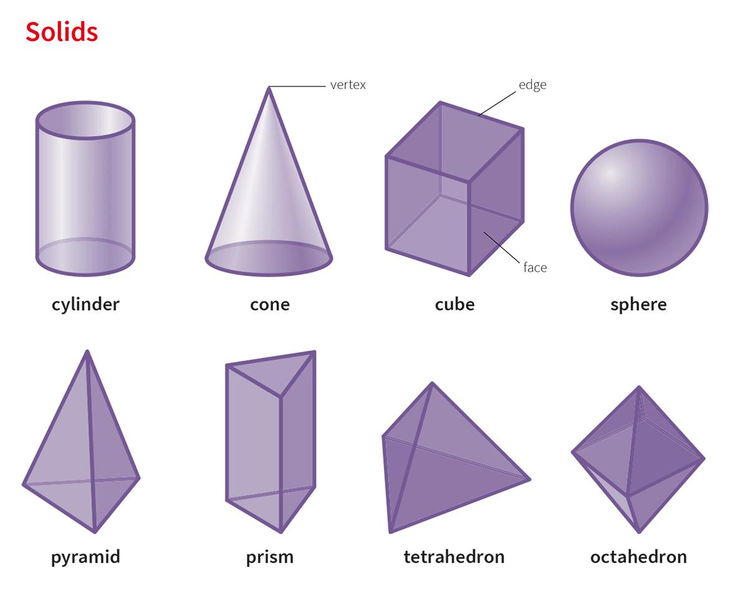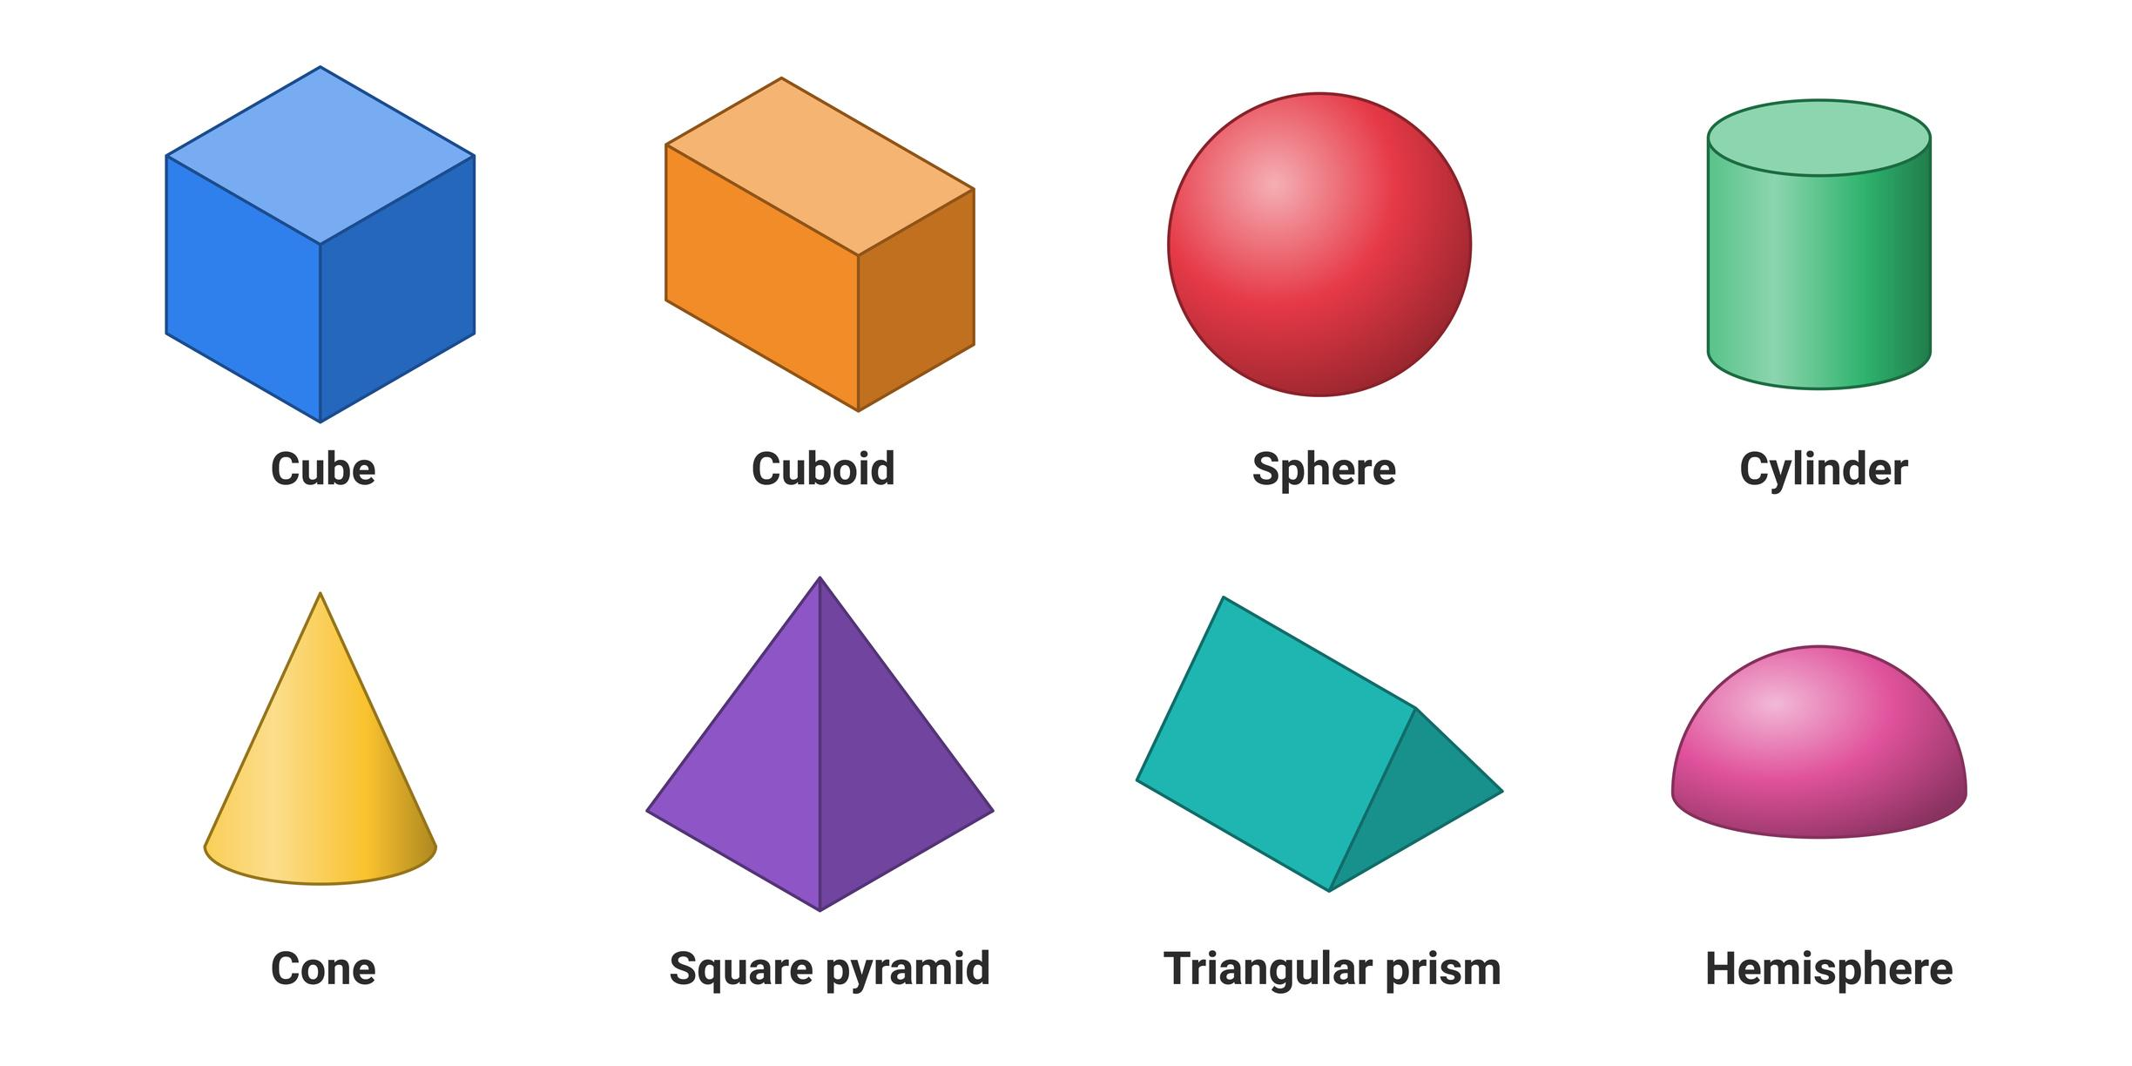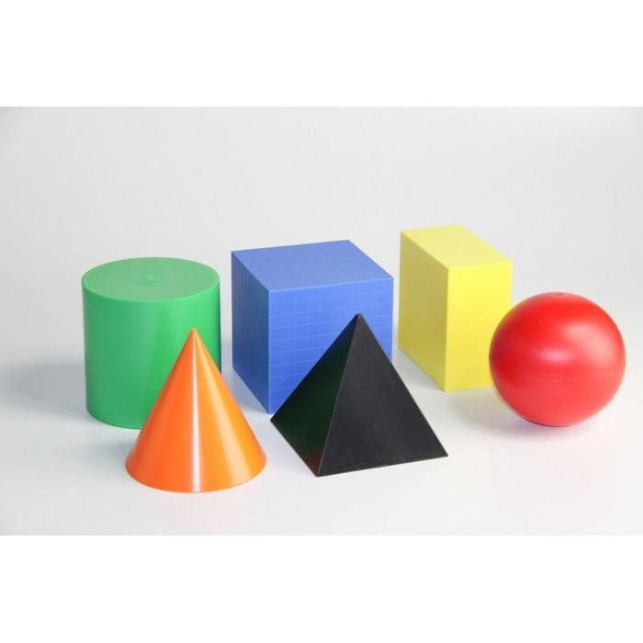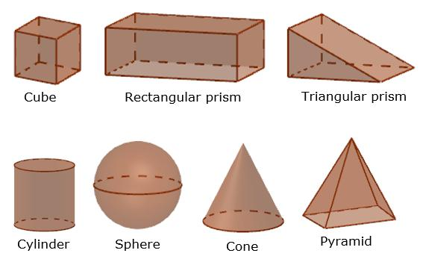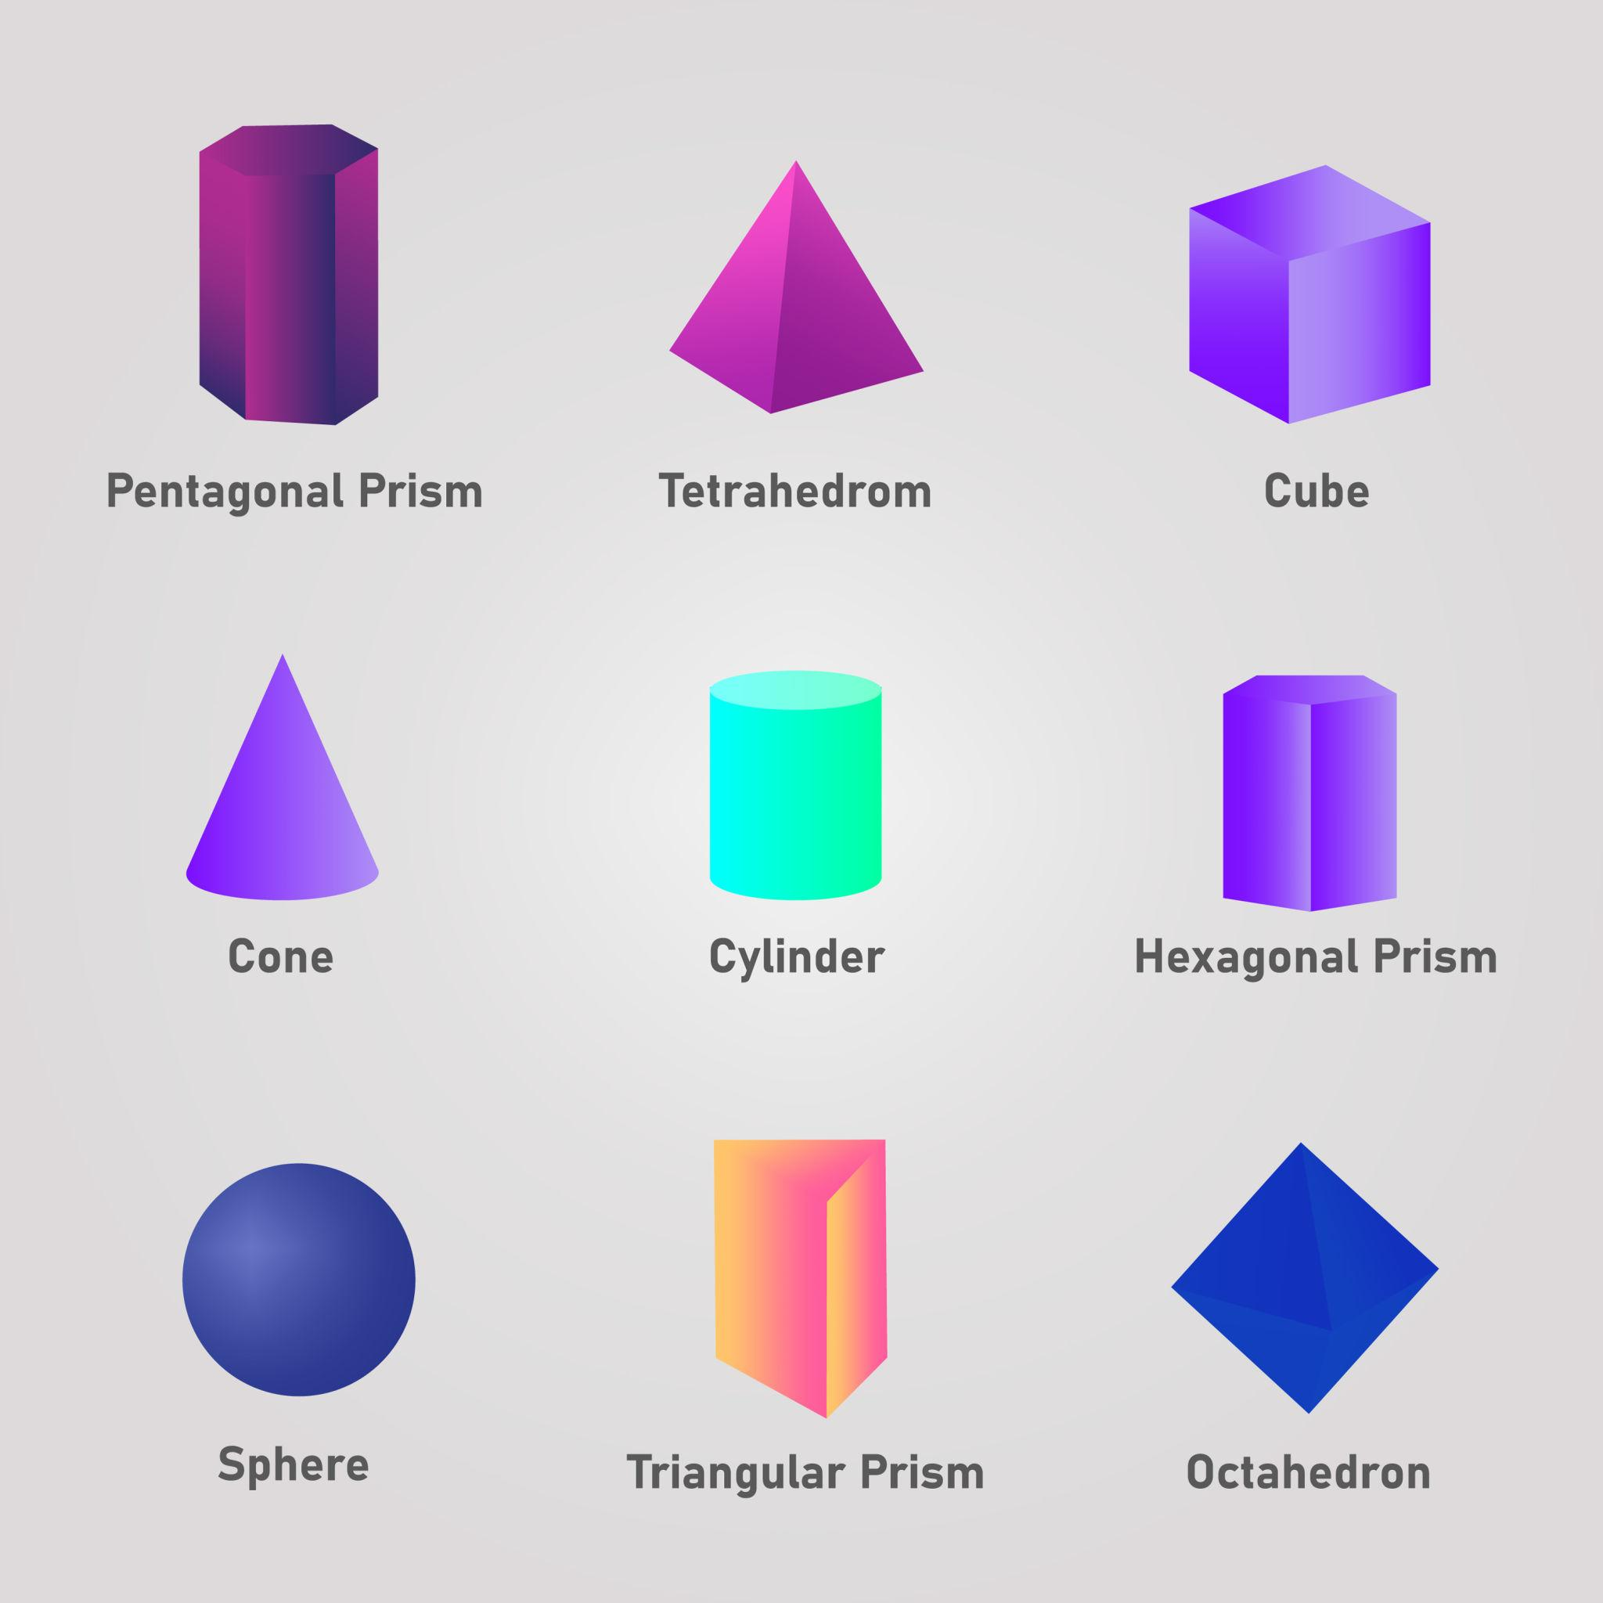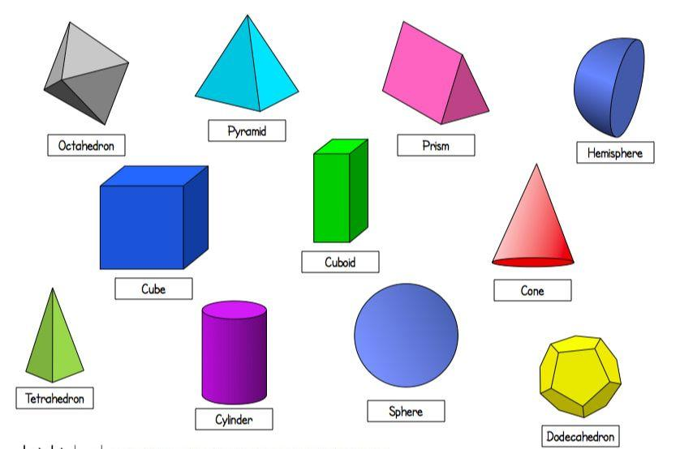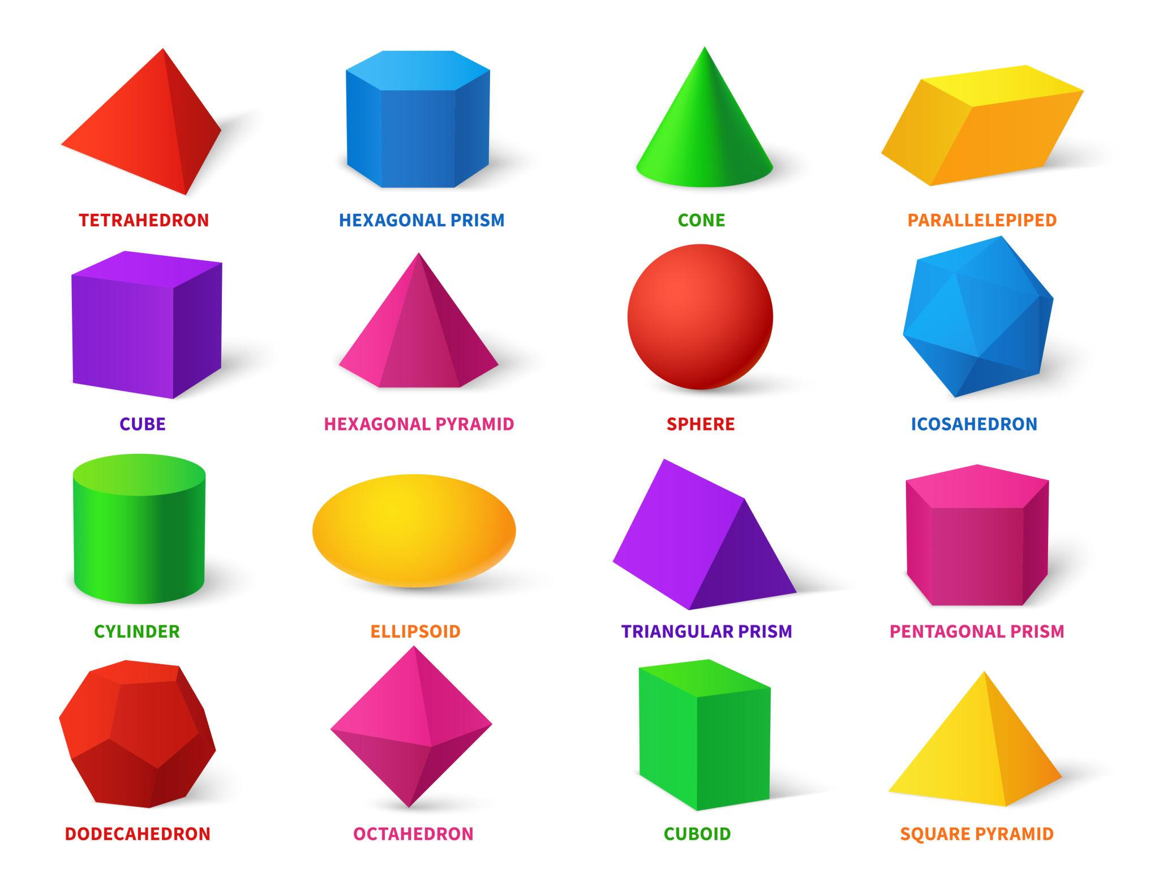

Geometric Structure
# Source: AI Source: Provided by: [Data Path: Persons Table -> ID Column: 1, Name_En Column: Motasem Essam] -> From: [ChatGPT] on [7/25/2026]
Convex solids have the following characteristics:
- Continuous Interior: The interior forms a convex region without inward indentations.
- Convex Boundary: The boundary encloses a convex three-dimensional region.
- Line-Segment Property: Every segment joining two points in the solid remains inside or on its boundary.
- Convex Cross-Sections: Every planar cross-section is a convex two-dimensional figure.
- Convex Hull: The convex hull of the solid is identical to the solid itself.
- Connected Intersections: Any straight line intersects a convex solid in at most one connected interval, a single point, or not at all.

Mathematical Definition
# Source: AI Source: Provided by: [Data Path: Persons Table -> ID Column: 1, Name_En Column: Motasem Essam] -> From: [ChatGPT] on [7/25/2026]
Let $S$ represent a three-dimensional solid.
The solid is convex if, for every pair of points $P,Q∈S$, the following condition is satisfied:
$$\boxed{(1-t)P+tQ∈S}$$
for every:
$$0≤t≤1$$
Here:
- $P$ = First point in the solid.
- $Q$ = Second point in the solid.
- $t$ = A real number between 0 and 1.
- $(1-t)P+tQ$ = Any point along the line segment joining $P$ and $Q$.
This condition must hold for every possible pair of points in the solid.

Classification of Convex Solids
# Source: AI Source: Provided by: [Data Path: Persons Table -> ID Column: 1, Name_En Column: Motasem Essam] -> From: [ChatGPT] on [7/25/2026]
Convex solids can be organized into the following geometric groups:

Convex Polyhedra
# Source: AI Source: Provided by: [Data Path: Persons Table -> ID Column: 1, Name_En Column: Motasem Essam] -> From: [ChatGPT] on [7/25/2026]
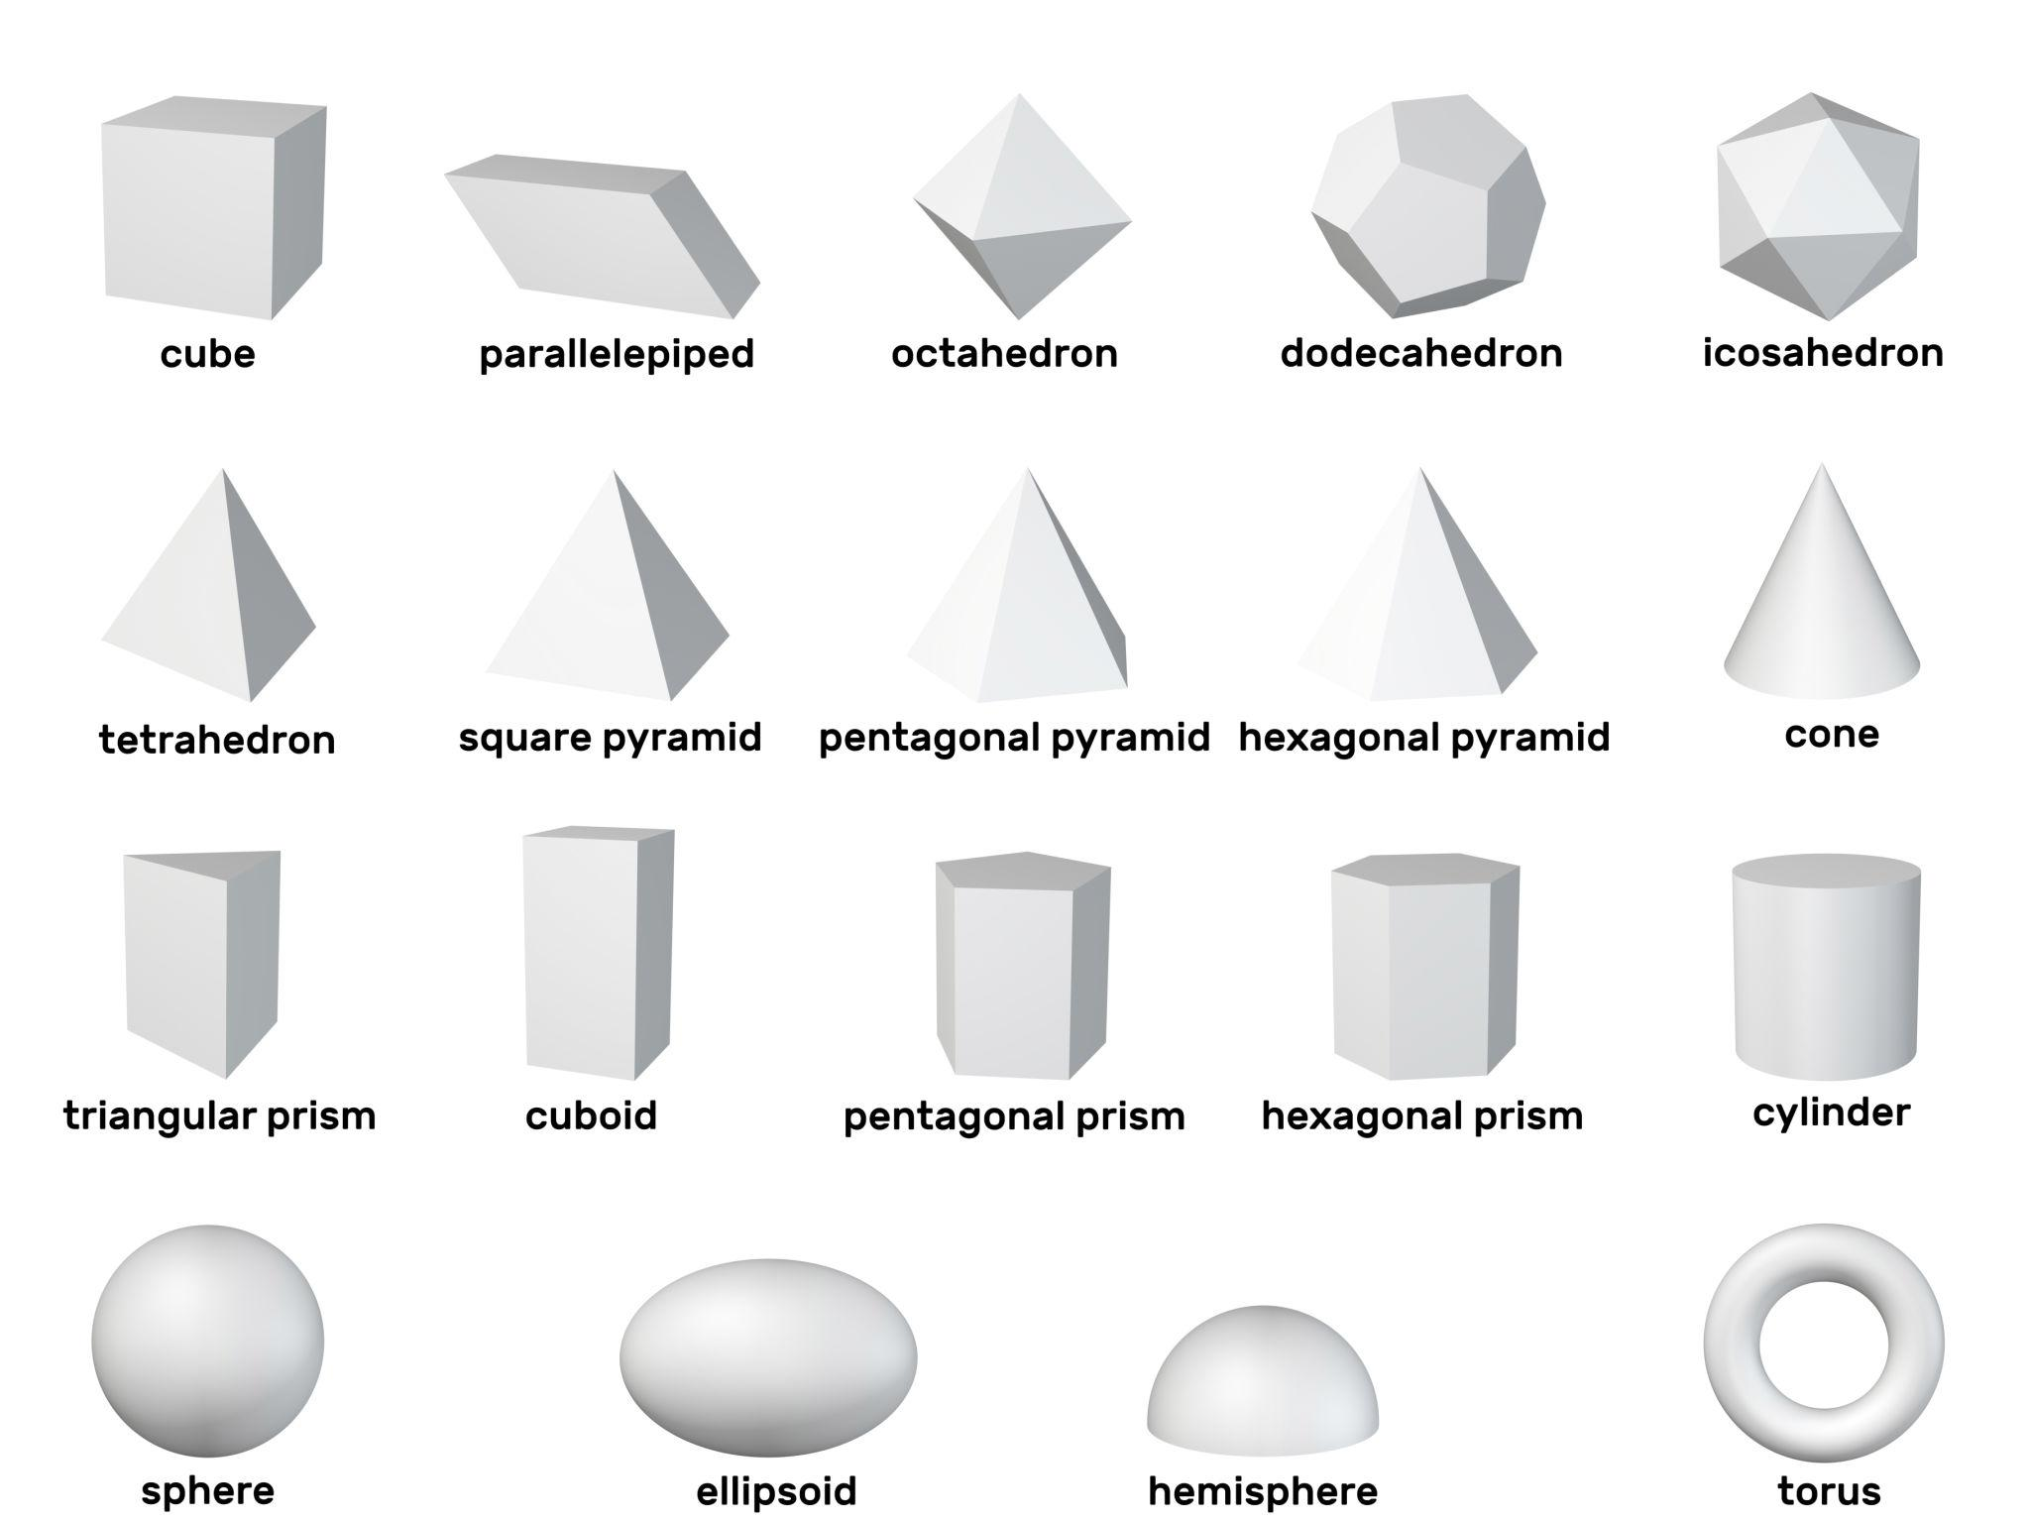
Solids bounded entirely by flat convex polygonal faces.

Convex Curved Solids
# Source: AI Source: Provided by: [Data Path: Persons Table -> ID Column: 1, Name_En Column: Motasem Essam] -> From: [ChatGPT] on [7/25/2026]
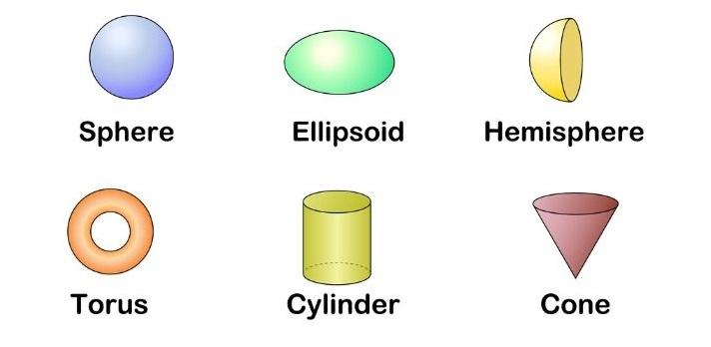
Solids with curved surfaces that enclose convex regions.

Convex Composite Solids
# Source: AI Source: Provided by: [Data Path: Persons Table -> ID Column: 1, Name_En Column: Motasem Essam] -> From: [ChatGPT] on [7/25/2026]
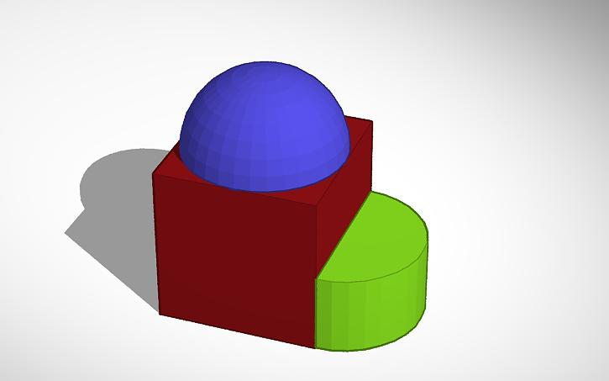
Solids formed by combining simpler solids while preserving convexity.

Convex Polyhedra

Definition
# Source: AI Source: Provided by: [Data Path: Persons Table -> ID Column: 1, Name_En Column: Motasem Essam] -> From: [ChatGPT] on [7/25/2026]
Convex Polyhedra are three-dimensional polyhedra bounded by flat polygonal faces, where every line segment connecting any two points in the polyhedron remains entirely inside or on its boundary.
Their faces are convex polygons, and their overall structure contains no inward indentations.

Geometric Characteristics
# Source: AI Source: Provided by: [Data Path: Persons Table -> ID Column: 1, Name_En Column: Motasem Essam] -> From: [ChatGPT] on [7/25/2026]
- Bounded by flat polygonal faces.
- Have straight edges and vertices.
- Every face is a convex polygon.
- Have no inward-facing indentations.
- Their interiors satisfy the convexity condition.
- Can be regular, semiregular, or irregular.

Types of Convex Polyhedra
# Source: AI Source: Provided by: [Data Path: Persons Table -> ID Column: 1, Name_En Column: Motasem Essam] -> From: [ChatGPT] on [7/25/2026]
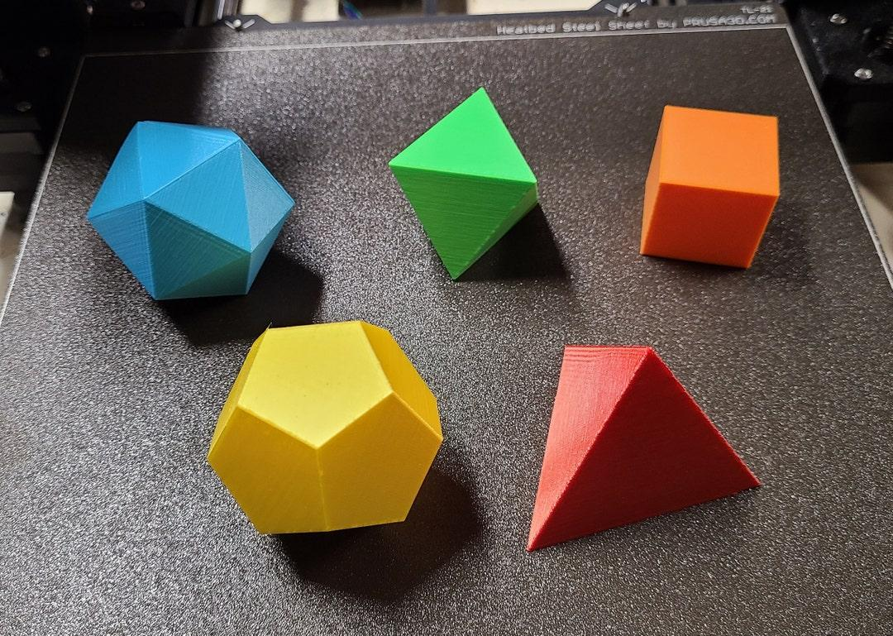
Platonic Solids
Five convex regular polyhedra.
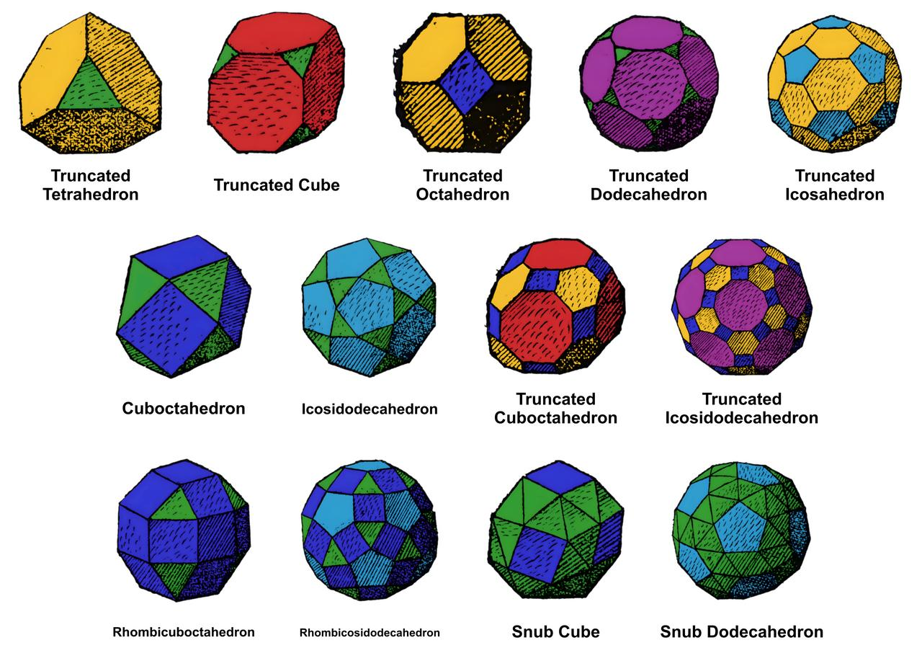
Archimedean Solids
Convex semiregular polyhedra.
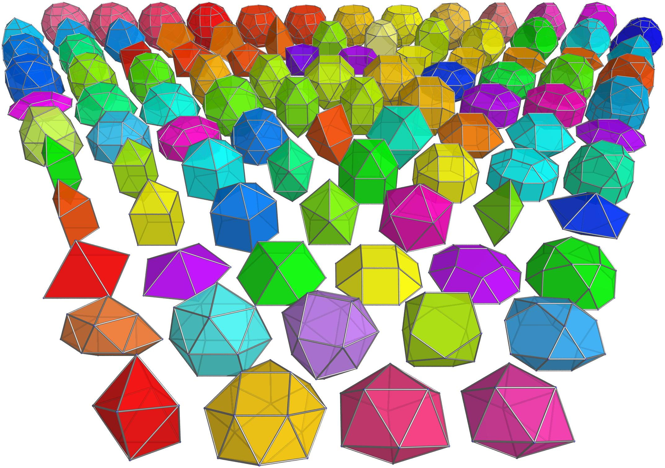
Johnson Solids
Convex polyhedra with regular polygonal faces.
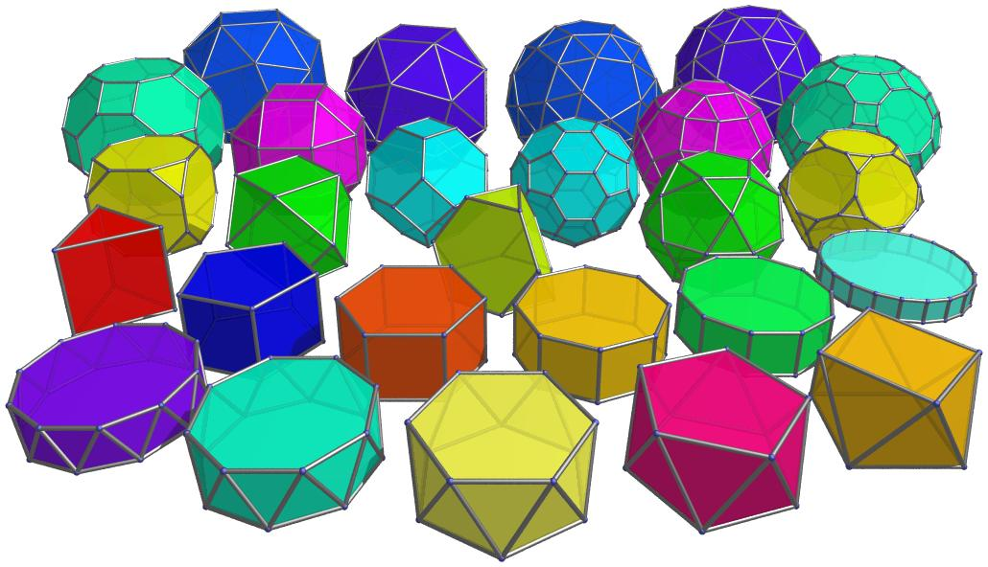
Prisms and Antiprisms
Convex forms with convex polygonal bases.
Other examples include:
- Convex Pyramids.
- Convex Frustums.
- Convex Bipyramids.
- Convex Trapezohedra.
- Convex Dipyramids.

Convex Curved Solids

Definition
# Source: AI Source: Provided by: [Data Path: Persons Table -> ID Column: 1, Name_En Column: Motasem Essam] -> From: [ChatGPT] on [7/25/2026]
Convex Curved Solids are three-dimensional solids with curved boundary surfaces that enclose a convex region.
They satisfy the same line-segment condition as convex polyhedra, but their boundaries may contain curved surfaces rather than only flat polygonal faces.

Geometric Characteristics
# Source: AI Source: Provided by: [Data Path: Persons Table -> ID Column: 1, Name_En Column: Motasem Essam] -> From: [ChatGPT] on [7/25/2026]
- Contain one or more curved boundary surfaces.
- Have convex interiors.
- Every connecting segment between two points remains inside or on the solid.
- Their planar cross-sections are convex.
- They may have circular, elliptical, spherical, or other curved profiles.

Types and Examples
# Source: AI Source: Provided by: [Data Path: Persons Table -> ID Column: 1, Name_En Column: Motasem Essam] -> From: [ChatGPT] on [7/25/2026]
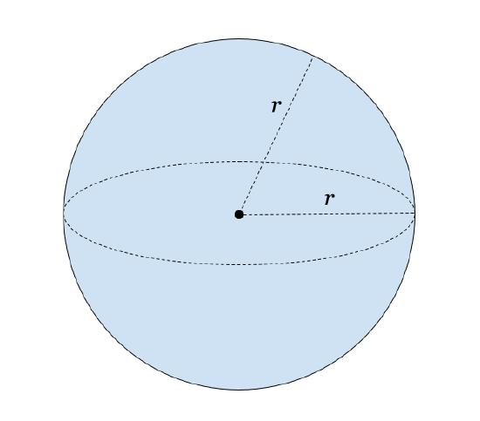
Sphere
A completely curved convex solid.
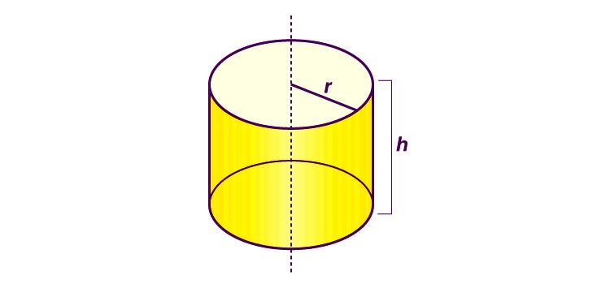
Cylinder
Two circular bases and a curved lateral surface.
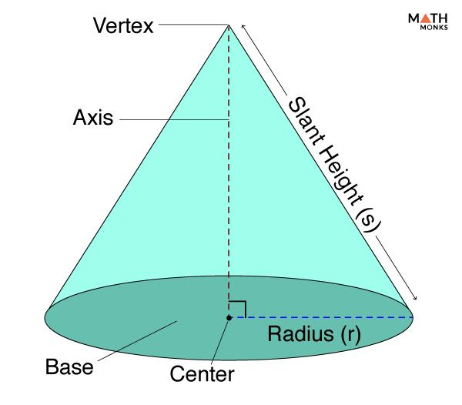
Cone
A circular base and a curved lateral surface.
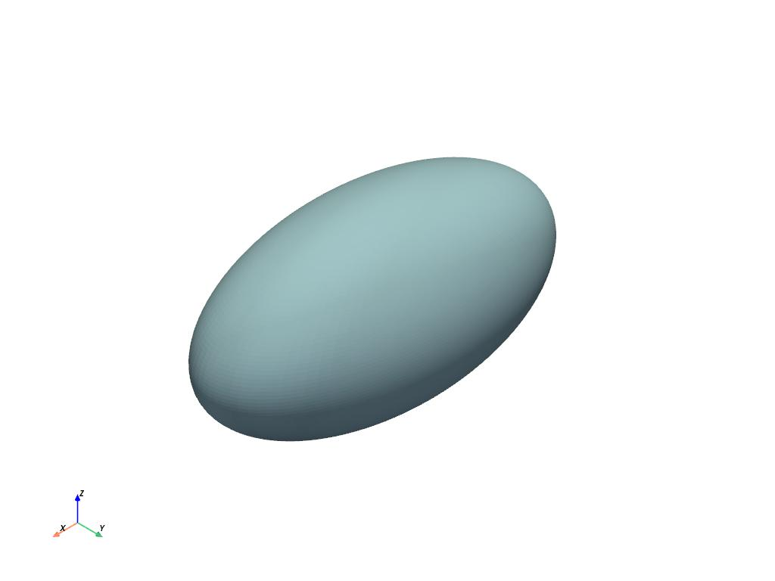
Ellipsoid
An elongated or flattened spherical solid.
Additional examples include:
- Spherical Caps.
- Spherical Segments.
- Solid Hemispheres.
- Ellipsoidal Segments.
- Convex Paraboloids with bounded bases.

Convex Composite Solids

Definition
# Source: AI Source: Provided by: [Data Path: Persons Table -> ID Column: 1, Name_En Column: Motasem Essam] -> From: [ChatGPT] on [7/25/2026]
Convex Composite Solids are solids formed by combining two or more simpler geometric solids in a way that produces a single convex three-dimensional region.
Their component solids may be polyhedral, curved, or a combination of both.
The resulting solid must satisfy the convexity condition, regardless of the shapes used to construct it.

Geometric Characteristics
# Source: AI Source: Provided by: [Data Path: Persons Table -> ID Column: 1, Name_En Column: Motasem Essam] -> From: [ChatGPT] on [7/25/2026]
- Formed from two or more component solids.
- May combine polyhedral and curved components.
- Have a continuous convex interior.
- Contain no inward indentations in their overall geometry.
- Their component arrangement must preserve convexity.

Examples
# Source: AI Source: Provided by: [Data Path: Persons Table -> ID Column: 1, Name_En Column: Motasem Essam] -> From: [ChatGPT] on [7/25/2026]
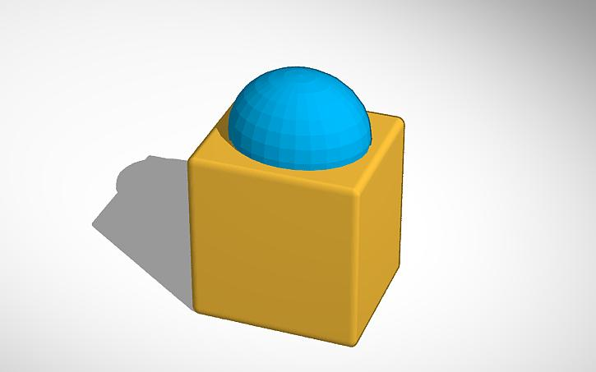
Prism with Hemisphere
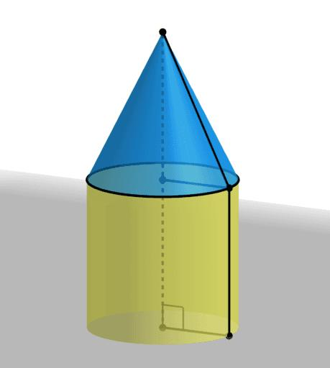
Cylinder with Cone
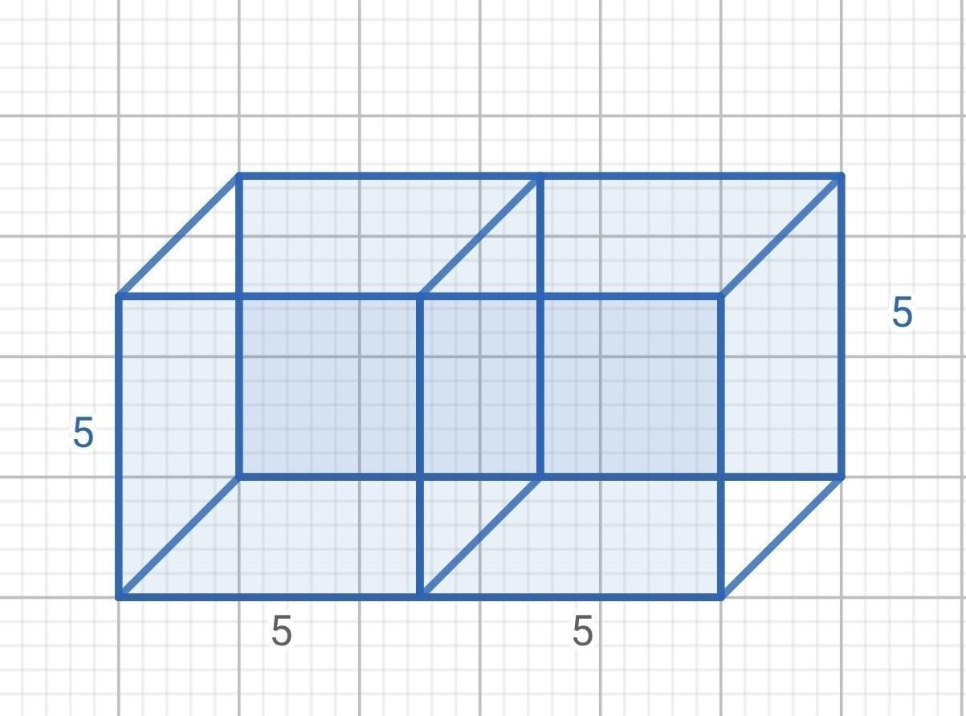
Joined Prisms
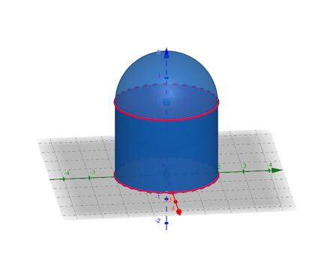
Cylinder with Spherical Cap
Important: Combining convex solids does not automatically produce a convex composite solid. Their placement and the way they are joined must preserve the line-segment property.
For example, two cubes joined along complete matching faces can form a larger convex cuboid, whereas an L-shaped arrangement of cubes is non-convex.

Mathematical Properties
# Source: AI Source: Provided by: [Data Path: Persons Table -> ID Column: 1, Name_En Column: Motasem Essam] -> From: [ChatGPT] on [7/25/2026]
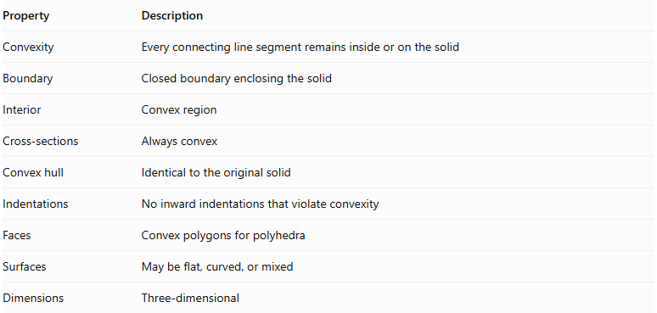
Property | Description
Convexity | Every connecting line segment remains inside or on the solid
Boundary | Closed boundary enclosing the solid
Interior | Convex region
Cross-sections | Always convex
Convex hull | Identical to the original solid
Indentations | No inward indentations that violate convexity
Faces | Convex polygons for polyhedra
Surfaces | May be flat, curved, or mixed
Dimensions | Three-dimensional

Convex Hull
# Source: AI Source: Provided by: [Data Path: Persons Table -> ID Column: 1, Name_En Column: Motasem Essam] -> From: [ChatGPT] on [7/25/2026]
The Convex Hull of a solid is the smallest convex set that completely contains that solid.
For a convex solid, the convex hull is equal to the original solid.
$$\boxed{Conv(S)=S}$$
This property provides another way to characterize convex solids.

Relationship to Other Geometric Classifications
# Source: AI Source: Provided by: [Data Path: Persons Table -> ID Column: 1, Name_En Column: Motasem Essam] -> From: [ChatGPT] on [7/25/2026]
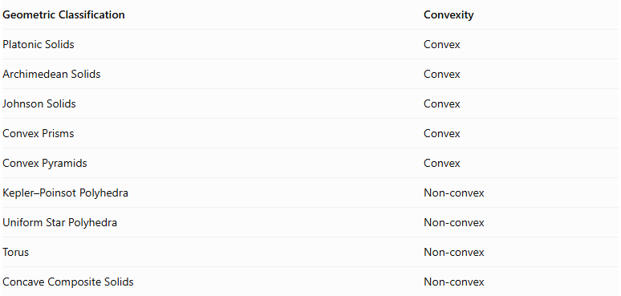
Geometric Classification | Convexity
Platonic Solids | Convex
Archimedean Solids | Convex
Johnson Solids | Convex
Convex Prisms | Convex
Convex Pyramids | Convex
Kepler–Poinsot Polyhedra | Non-convex
Uniform Star Polyhedra | Non-convex
Torus | Non-convex
Concave Composite Solids | Non-convex
Convexity is independent of regularity and surface type. A solid can be regular or irregular, polyhedral or curved, and still be convex.

Main Classification
# Source: AI Source: Provided by: [Data Path: Persons Table -> ID Column: 1, Name_En Column: Motasem Essam] -> From: [ChatGPT] on [7/25/2026]
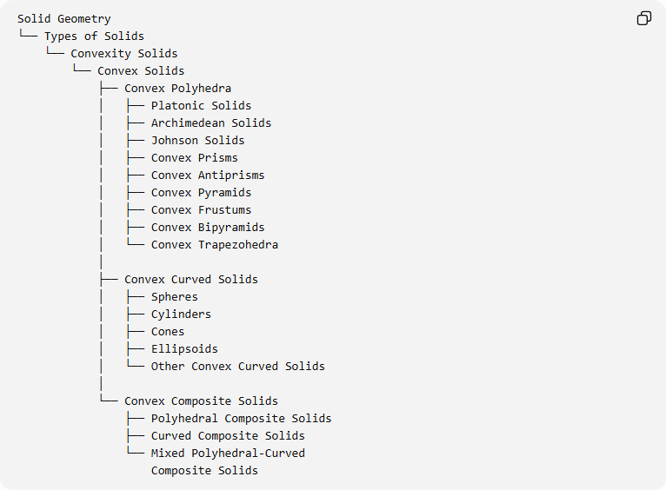
Solid Geometry
└── Types of Solids
└── Convexity Solids
└── Convex Solids
├── Convex Polyhedra
│ ├── Platonic Solids
│ ├── Archimedean Solids
│ ├── Johnson Solids
│ ├── Convex Prisms
│ ├── Convex Antiprisms
│ ├── Convex Pyramids
│ ├── Convex Frustums
│ ├── Convex Bipyramids
│ └── Convex Trapezohedra
│
├── Convex Curved Solids
│ ├── Spheres
│ ├── Cylinders
│ ├── Cones
│ ├── Ellipsoids
│ └── Other Convex Curved Solids
│
└── Convex Composite Solids
├── Polyhedral Composite Solids
├── Curved Composite Solids
└── Mixed Polyhedral-Curved
Composite Solids

Key Points
# Source: AI Source: Provided by: [Data Path: Persons Table -> ID Column: 1, Name_En Column: Motasem Essam] -> From: [ChatGPT] on [7/25/2026]
- Convex solids are three-dimensional solids satisfying the line-segment condition.
- They have no inward indentations that violate convexity.
- Their cross-sections are always convex.
- Their convex hull is identical to the original solid.
- They include polyhedral, curved, and composite solids.
- All five Platonic solids are convex.
- All Archimedean and Johnson solids are convex.
- Convexity must be preserved when combining component solids.
- Convexity is independent of regularity and the type of boundary surface.

Conclusion
# Source: AI Source: Provided by: [Data Path: Persons Table -> ID Column: 1, Name_En Column: Motasem Essam] -> From: [ChatGPT] on [7/25/2026]
Convex Solids form one of the two fundamental branches of convexity-based solid classification. They include a wide variety of geometric structures, from regular polyhedra and curved solids to composite constructions. Their defining characteristic is that every line segment connecting two points within the solid remains entirely inside or on its boundary.

